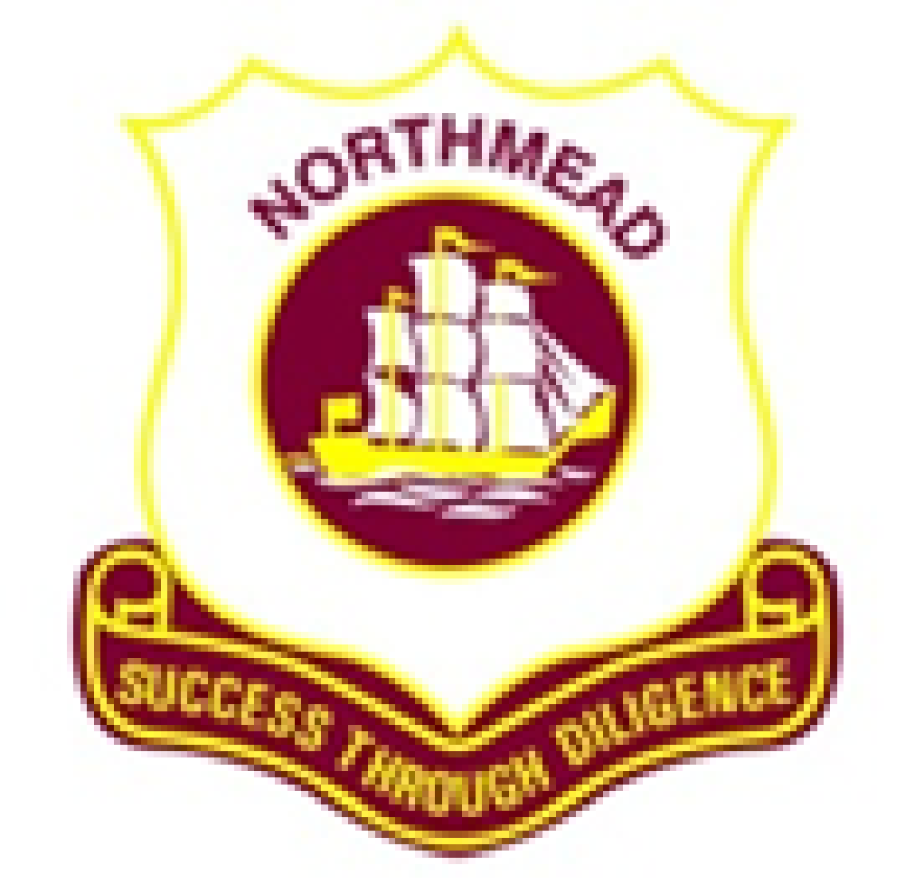

NORTHMEAD CAPA HIGH SCHOOL

PBL KLA Assessment Task: Year 10

Science and PD/H/PE

**Concept – Survival**

## Driving question: Is crash survival a matter of luck?

In week 8, September 4th- September 8th , students in Year10 will all take part in a Project Based Learning Task where they consider the importance of driver safety and survival on the roads. During this week, normal classes will be disbanded while the students work in groups to create a safety presentation and car prototype which would provide protection for a passenger. Students will also be attending presentations from:

* **Blue Datto Foundation** http://www.bluedatto.org.au The main outcome of this program is a personal young driver and passenger road safety plan. It includes small group activities and larger group presentations as well as a visit from the local Police.
* **Wentworthville Fire & Rescue** will be presenting their NSW RescueEd program which includes a practical demonstration simulating the rescue of a person from a motor vehicle.

It is important to note that during these presentations, students will view television commercials and visuals that depict car crashes. Any students who might find this confronting MUST speak to Miss Spicer, Ms Miller or Mrs Fuccilli by the 1st September so that they can be withdrawn from the activity.

Having learnt information relating to car safety, the students will be asked to create a safety presentation and create an ‘egg mobile’ – a prototype of a vehicle which will be run through a specific crash simulation to test its ability to safely protect an egg.

Each group of students will be provided with basic material kit to build their vehicle including:

* 1m bubble wrap
* 2m twine
* 8 rubber bands
* 1 small roll of sticky tape
* 1 disposable rectangular takeaway box
* 50 paddle-pop sticks
* 3 sheets of A4 card weight paper

Each group will be responsible for providing wheels and axles for their prototype and any other materials that they would like to add. These may be prefabricated.

The egg mobile will need to be built to specific criteria which will be handed out on Monday 4th September.

This will be a very interesting and informative week for students in year 10 as they engage with a mandatory project for Science and PD/H/PE and learn about the importance of safety on the roads.

Should you have any concerns regarding this project, please contact Miss Spicer at school.