YEAR 7 Project Based Learning: SAFETY

Date Issued: Wk 2 T1 2018 | Course: Cross Faculty Project
Due: Friday 2ND March Wk 5 T1 2018 | Student Name:

Task Name: YEAR 7 Project Based Learning: SAFETY
Task Weight: As per each subjects Assessment Schedule
Time to complete the task: 3 Weeks

The following outcomes will be assessed:
Science – SC4-6WS A student follows a sequence of instructions to safely undertake a range of investigation types, collaboratively and individually.
TAS – 4.3.2 Demonstrate responsible and safe use of a range of tools, materials and techniques in each design project.
PDHPE – 71F Identifies the consequences of risk behaviours in physical activity and describes strategies to minimise harm

Task Description
This task has 2 parts.
- Creating a digital resource: In groups of 4/5 create a digital resource to be presented to a year 7 audience based on the driving question below.

How do we make Northmead classrooms safe environments?

Your presentation needs to specifically relate to Science, TAS and PDHPE. The resource could include but is not limited to the following suggestions:

Website | Glogster | PowerPoint | Interactive worksheet with hyperlinks
Movie/video | Animation | Prezi

BE CREATIVE AND APPEAL TO YOUR AUDIENCE!

- Describe how your team worked together by completing the template provided to you on Google Classroom.

How to submit your work:
Upload to the Google Classroom: Year 7 PBL 2017: Safety. In there, look for the assessment announcement with your class letter (see the example on the next page)

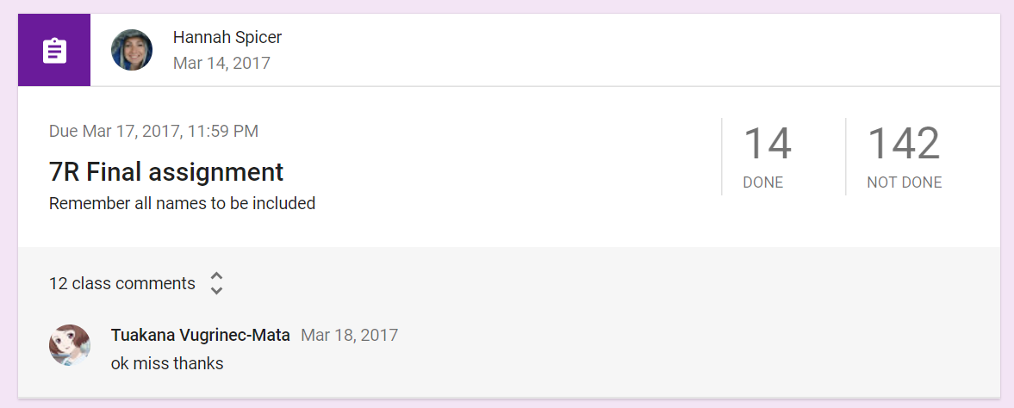

This indicates that all students belonging to 7R Science would upload here

Marking Criteria Faculty: PDHPE/TAS/SCIENCE (20 marks)

- Demonstrates outstanding knowledge and understanding of safety rules applied to practical lessons across all 3 subject areas.  - Demonstrates outstanding control of digital text form appropriate to audience and purpose.  - Presents all information in an engaging and cohesive manner. | 17-20
- Demonstrates good knowledge and understanding of safety rules applied  to practical lessons across all 3 subject areas.  - Demonstrates good control of digital text form appropriate to audience and purpose.  - Presents information mostly in an engaging and cohesive manner. | 13-16
- Demonstrates sound knowledge and understanding of safety rules applied to practical lessons across at least 2 subject areas.  - Demonstrates sound control of digital text form appropriate to audience and purpose.  - Presents information in a cohesive manner. | 9 -12
- Demonstrates basic knowledge and understanding of safety rules applied to practical lessons in at least 2 subject areas.  - Demonstrates basic control of digital text form appropriate to audience and purpose.  - Presents basic information. May not be cohesive or engaging. | 5 -8
- Demonstrates limited knowledge and understanding of safety rules applied to practical lessons in at least 1 subject area.  - Demonstrates limited control of digital text form appropriate to audience and purpose.  - Fails to present information required. | 0 -4

